# COMP1150/MMCC1011 Game Design Task Report

**Name**: Ngoc Lan Tran

**Student ID**: 44480636  
**GitHub username: 44480636**

Unity features used in this assignment:

|  |  |  |
| --- | --- | --- |
| **Effect / Feature** | **Marks** | **Check if used** |
| An **outdoor** section built using the Terrain editor | 25% | **✓** |
| An **indoor** section built using Unity primitives (cubes, spheres, etc) and/or ProBuilder | 25% | **✓** |
| A **First Person controller** with which the player can navigate the scene. | - | **✓** |
| Appropriate [textures](https://docs.unity3d.com/Manual/Shaders.html) on the indoor section | 5% | **✓** |
| Textures with [normal maps](https://docs.unity3d.com/Manual/StandardShaderMaterialParameterNormalMap.html) | 5% | **✓** |
| A simple single-state [animation clips](https://docs.unity3d.com/Manual/animeditor-UsingAnimationEditor.html) | 5% | **✓** |
| A [multi-state animation](https://docs.unity3d.com/Manual/AnimationStateMachines.html) that responds to trigger or mouse events | 5% |  |
| Direct [light sources](https://docs.unity3d.com/Manual/LightSources.html) beyond the default Directional Light | 5% | **✓** |
| [Baked indirect lighting](https://docs.unity3d.com/Manual/LightMode-Baked.html) in the Indoor section | 5% |  |
| Use of [light-probes](https://docs.unity3d.com/Manual/LightProbes.html) for dynamic indirect lighting | 5% |  |
| Use of [reflection-probes](https://docs.unity3d.com/Manual/ReflectionProbes.html) and reflective surfaces | 5% | **✓** |
| Appropriately chosen [post-processing effects](https://docs.unity3d.com/Manual/PostProcessingOverview.html) | 5% | **✓** |
| Use of [multiple cameras](https://docs.unity3d.com/Manual/CamerasOverview.html) (e.g. overlaid cameras or rendering to a texture) | 10% | **✓** |
| [Particle systems](https://docs.unity3d.com/Manual/ParticleSystems.html) | 10% | **✓** |
| Objects controlled by [physics](https://docs.unity3d.com/Manual/PhysicsSection.html) | 5% | **✓** |
| Using [joints](https://docs.unity3d.com/Manual/Joints.html) | 5% | **✓** |
| Appropriate 3D spatialised [audio sources](https://docs.unity3d.com/Manual/AudioOverview.html) | 5% |  |
| Using [reverb zones](https://docs.unity3d.com/Manual/class-AudioReverbZone.html)**,**[effects](https://docs.unity3d.com/Manual/class-AudioEffectMixer.html) and [filters](https://docs.unity3d.com/Manual/class-AudioEffect.html) | 5% |  |
| **TOTAL:** | 110% |  |

**Note:** Totals greater than 100% will be rounded down.

On the following pages you should indicate where each of the above features appear in your game, using screenshots to direct the marker. You will not get marks for a feature that is not documented in your submitted report. Additionally, features will not receive marks if they cannot be easily located within your scene and hierarchy.

Ensure your completed report is both included in your assignment repository (on GitHub) and submitted via the Game Design Task submission link on iLearn. Submission of this report via iLearn notifies the markers that your Game Design Task GitHub repository is ready to be marked.

## 1. Terrain

**Features used**:

* An **outdoor** section built using the Terrain editor
* Textures with normal maps

**Where in Hierarchy**

* /Terrain

**Description**:

The terrain contains a road get in a valley which has mountains around and a lake in middle. Inside the lake, there is an island where puts the cabin with a wood bride. The environment is covered by fog. The ground is covered by grass, rock, and flowers.

**Screenshot**:

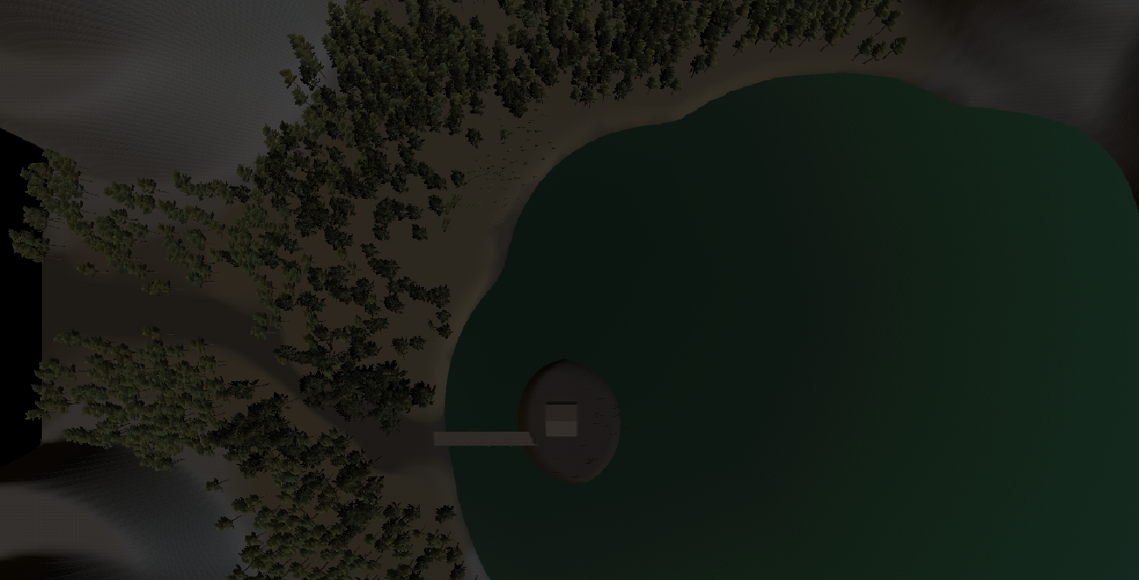

Figure 1: Top-view terrain

## 2. Environment:

**Features used**:

* Direct [light sources](https://docs.unity3d.com/Manual/LightSources.html) beyond the default Directional Light
* Textures with normal maps

**Where in Hierarchy**

* /Bridge
* /Gate Light
* /Sun Light
* /WinZone

**Description**:

The wooden bridge is built by ProBuilder cube and cylinder which link main ground to island. This has wood texture with normal maps. In the front of bridge, there is a gate light which is Baked point light.

The post-processor adds blooms, color grading and motion blur.

The Sun Light is direction light with color nearly black which present for nighttime.

The WinZone made the tree move.

**Screenshot**:

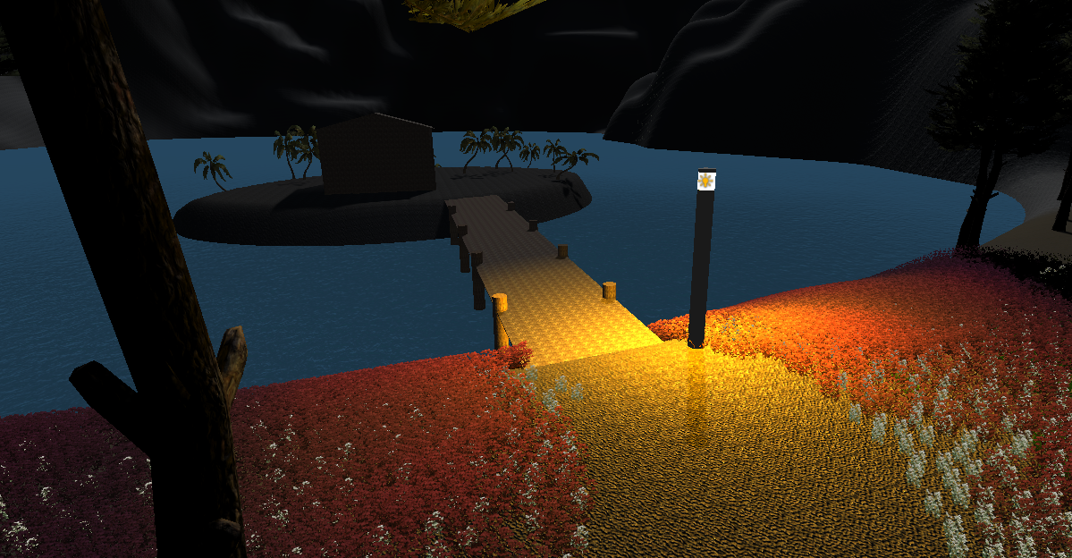

## 3. Cabin:

**Features used**:

* [Particle systems](https://docs.unity3d.com/Manual/ParticleSystems.html)
* Direct [light sources](https://docs.unity3d.com/Manual/LightSources.html) beyond the default Directional Light
* Use of [reflection-probes](https://docs.unity3d.com/Manual/ReflectionProbes.html) and reflective surfaces
* Textures with [normal maps](https://docs.unity3d.com/Manual/StandardShaderMaterialParameterNormalMap.html)
* Use of [multiple cameras](https://docs.unity3d.com/Manual/CamerasOverview.html)

**Where in Hierarchy**

* /House
* /Campfire
* /Tv
* /Reflection Probe

**Description**:

The indoor section uses the textures with normal maps

There is a campfire in middle of house and two wall fires which use Particle systems

There is a glass in the corner of house which reflect the inside of house including fire and wall which uses reflection-probes. The outside of house also reflects the environment around.

The picture in the wall uses use of multiple cameras to capture the picture of this word.

**Screenshot**:

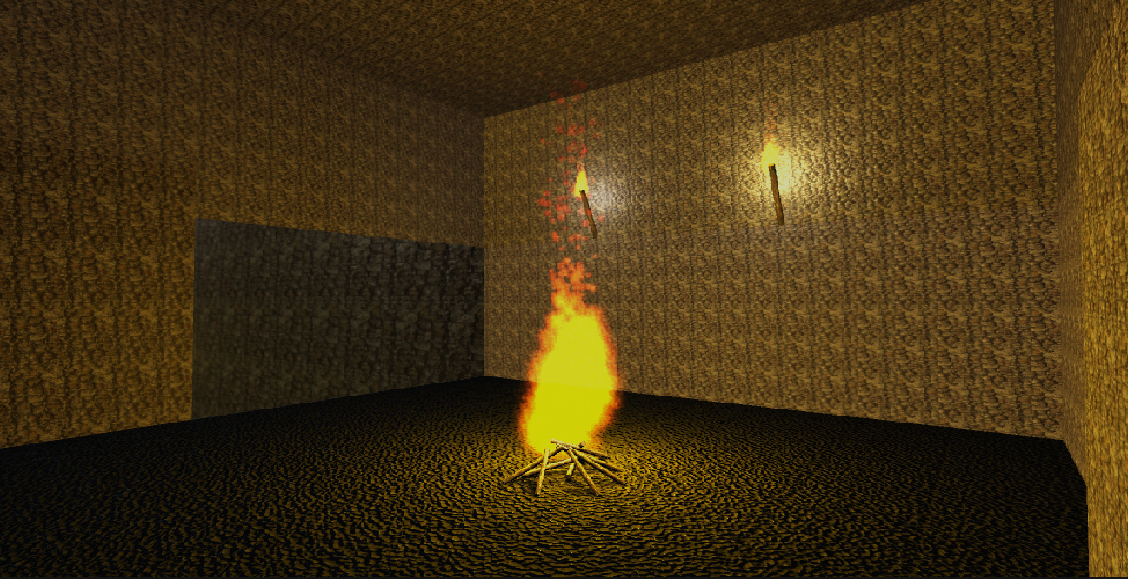

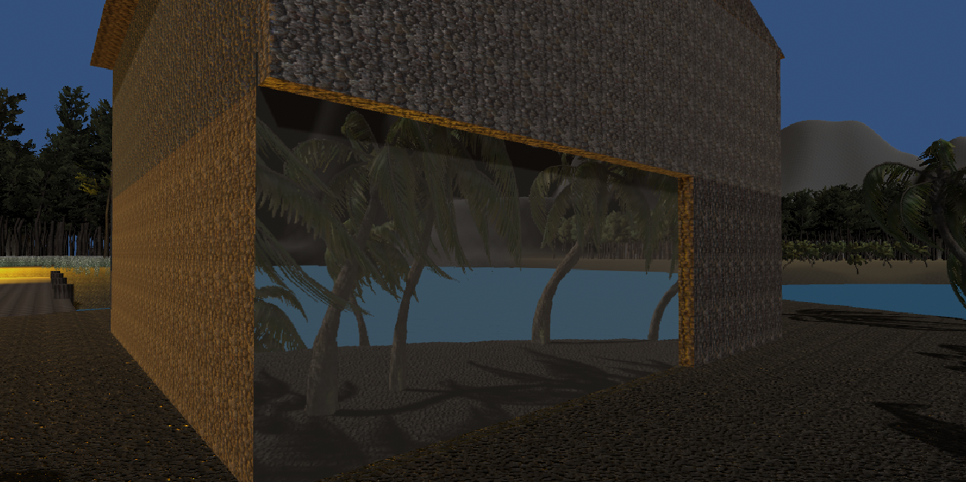

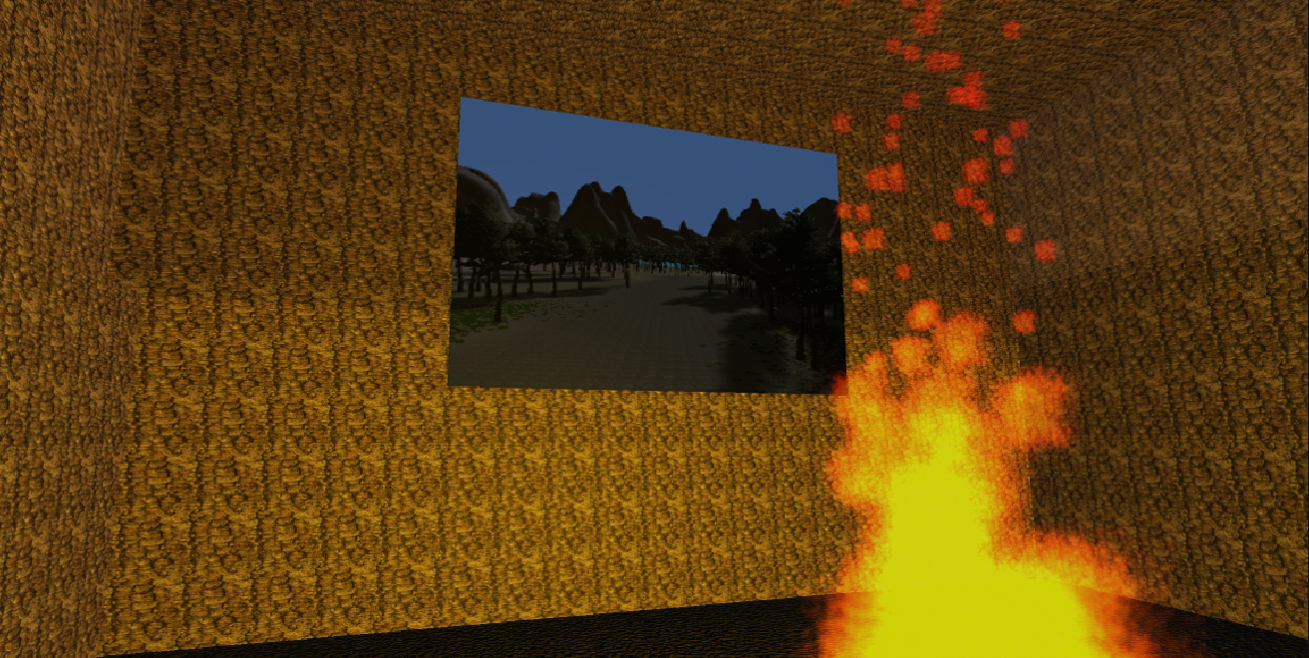

## 4.Door:

**Features used**:

* Using [joints](https://docs.unity3d.com/Manual/Joints.html)
* Textures with [normal maps](https://docs.unity3d.com/Manual/StandardShaderMaterialParameterNormalMap.html)
* Objects controlled by [physics](https://docs.unity3d.com/Manual/PhysicsSection.html)
* A simple single-state [animation clips](https://docs.unity3d.com/Manual/animeditor-UsingAnimationEditor.html)

**Where in Hierarchy**

* /House/Door Trigger

**Description**:

The door automatically open when player stand in front the door. This use hinge-joint and animation clips to slide the door to open. This uses TriggerToAnim.

**Screenshot**:

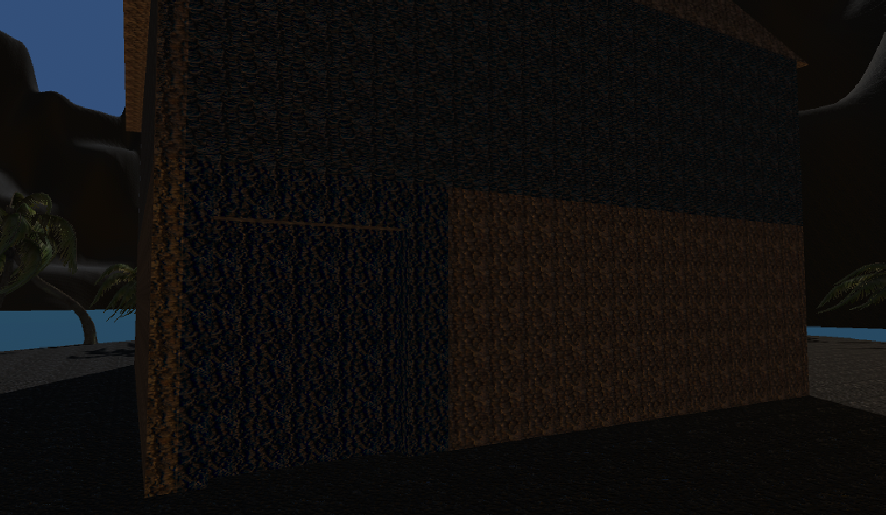

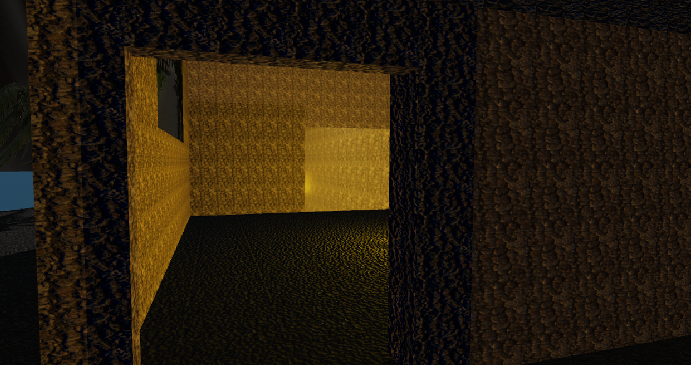

# Assets Used

## Textures

* Mountain Rock – Standard Assets (Environment), by Unity Technologies (from Asset Store)
* Light Rock – Standard Assets (Environment), by Unity Technologies (from Asset Store)
* Grass – Standard Assets (Environment), by Unity Technologies (from Asset Store)
* ConiferBark – Standard Assets (Environment), by Unity Technologies (from Asset Store)
* Cap-01 – Standard Assets (Environment), by Unity Technologies (from Asset Store)

## Details

* Flame, from practical week 11
* Ferns – Standard Assets (Environment), by Unity Technologies (from Asset Store)
* WhiteFlowers – Standard Assets (Environment), by Unity Technologies (from Asset Store)
* Conifer_Desktop – Standard Assets (Environment), by Unity Technologies (from Asset Store)
* Palm_Desktop – Standard Assets (Environment), by Unity Technologies (from Asset Store)
* Grass1Leaves – Standard Assets (Environment), by Unity Technologies (from Asset Store)

## Models

* WaterBasicNightime – Standard Assets (Environment), by Unity Technologies (from Asset Store)

## Scripts

* TriggerToAnim, from practical week 12

## Tools

* Terrain Tools, by Unity Technologies (from Package Manager)
* ProBuilder, by Unity Technologies (from Package Manager)
* Post Processing, by Unity Technologies (from Package Manager)